Source (MongoDB) Data format:

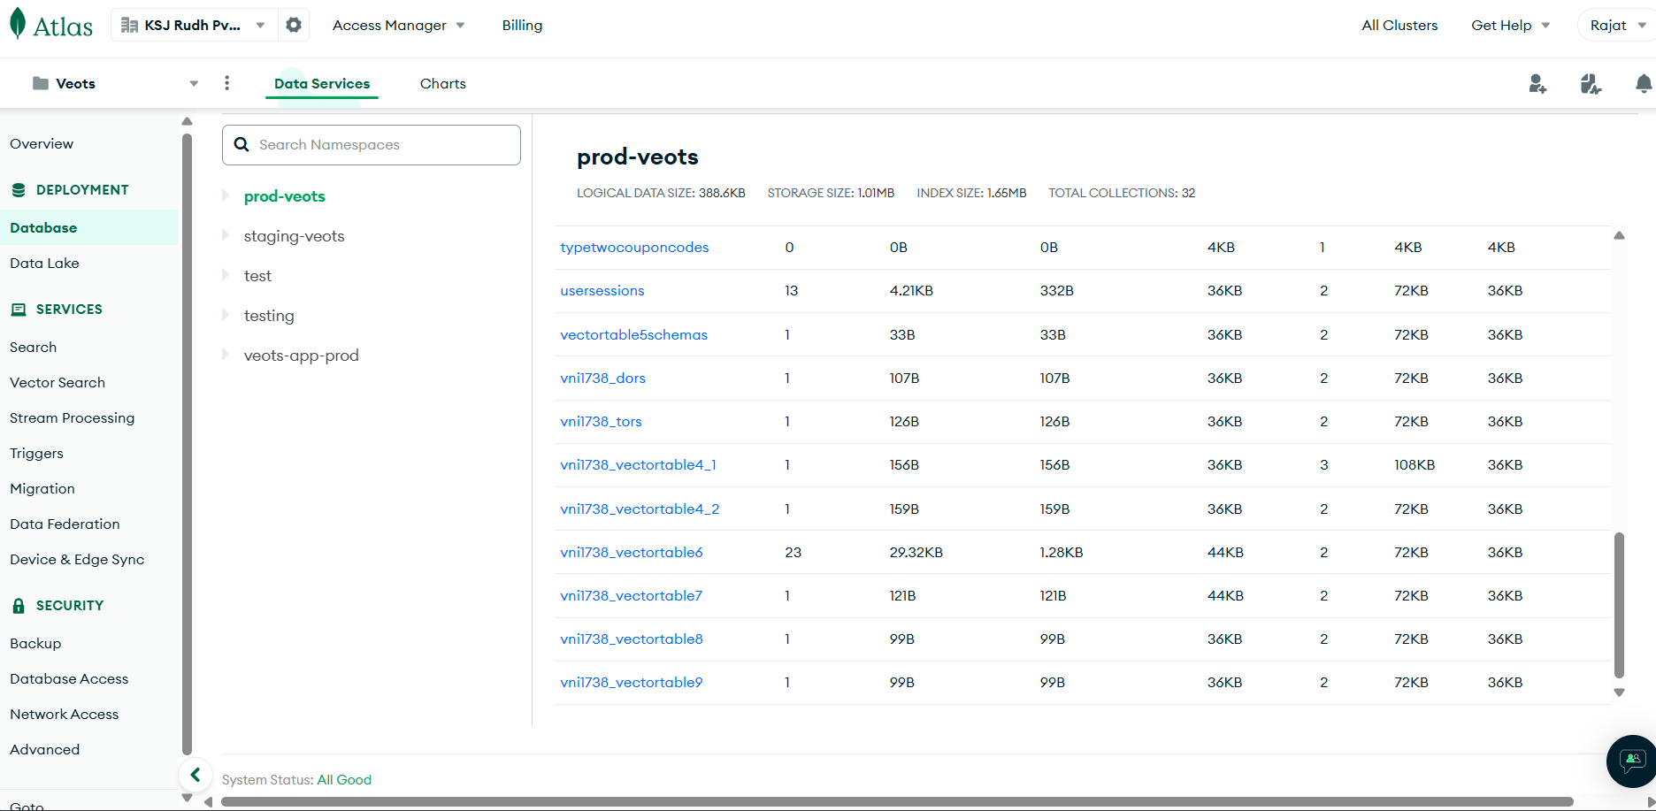

MongoDB is a popular NoSQL database designed to handle large volumes of unstructured or semi-structured data. Unlike traditional relational databases, which store data in tables with predefined schemas, MongoDB stores data in a flexible, document-oriented format using BSON (Binary JSON). This allows MongoDB to handle diverse data types and easily scale horizontally across multiple servers.  
  
[Veots_MongoDB_Schema](https://ksjrudhprivatelimited-my.sharepoint.com/:x:/r/personal/ranganadh_veots_com/_layouts/15/Doc.aspx?sourcedoc=%7B0F8C6624-D2C4-4B8B-8FE6-79A5252C1352%7D&file=Veots%20DB%20Schemas.xlsx&action=default&mobileredirect=true&wdOrigin=OFFICE-OFFICE-METAOS.FILEBROWSER.FILES-HOME)Above is the schema of the source database.

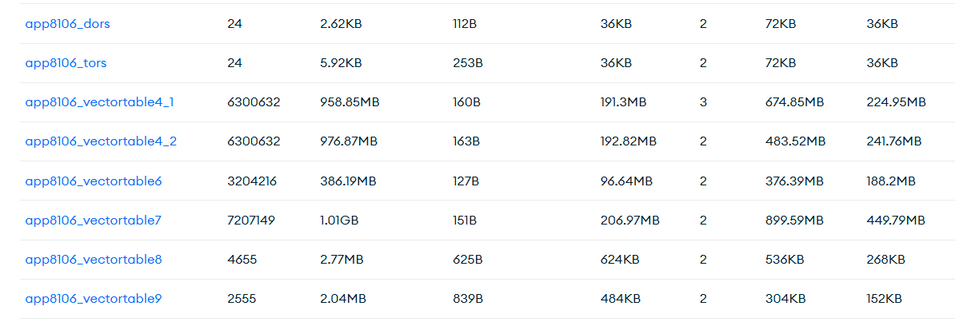Each client has 8 dynamic collections as shown above. The naming format of these collections is [client name]_[collection type]. For example in the above screenshot, "app8106” is the client name and ”dors”, ”tors”, ”vectortable_4_1”, ’vectortable_9” etc are the type of collections.

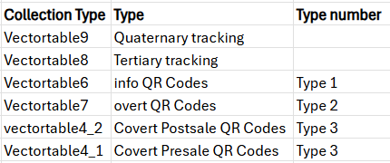  
Above is the description about what do all the types of dynamic collections consist.  
  
We extract all the collections that are needed for data analytics and store them into AWS S3 in the JSON format using AWS Glue job.